**Create Custom Tab at Header in Purchase Requistion**

created by [Siva rama Krishna Pabbraju](http://scn.sap.com/people/siva.pabbaraju) on Jun 5, 2014 8:15 PM, last modified by [Siva rama Krishna Pabbraju](http://scn.sap.com/people/siva.pabbaraju) on Jun 5, 2014 9:58 PM

Version 1

[Tweet](https://twitter.com/share)

As we all know we can create a custom tab at item level in Purchase Requistion and wonder is it possible to create custom tab in header lvel of Purchase Requistion ??

                       I have tried a lot by searching all the Function exists, Sreen exists and BADI but unable to find any enahcement . I even searched SAP forums but could not find any positive approach.At last I have found myself small information which lead to me to discover custom tab in Header level in Purchase Requistion.

[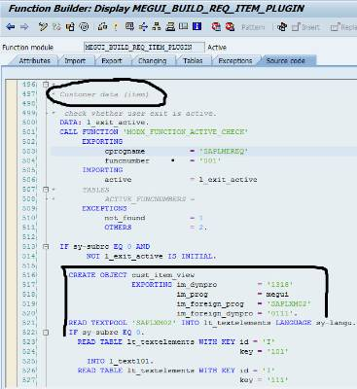](http://scn.sap.com/servlet/JiveServlet/showImage/102-55509-1-468857/6-3-2014+3-58-41+PM.jpg)

We can clealry see that CUSTOM TAB which we create '0111' in Program SAPLXM02  is register here. So there may possibilty for custom tab in header level also.With this intennt I tried hard to explore, than I FM -MEGUI_BUILD_REQ_HEADER_PLUGIN which enables custom tab at header level if we can create an implicit enahncment in it as shown below.

[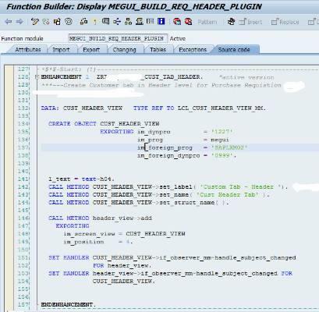](http://scn.sap.com/servlet/JiveServlet/showImage/102-55509-1-468859/6-6-2014+12-38-47+AM.jpg)

**--Declare a custom header view with ref to local class  LCL_CUST_HEADER_VIEW_MM of function pool MEGUI.

DATA: CUST_HEADER_VIEW   TYPE REF TO LCL_CUST_HEADER_VIEW_MM.

  CREATE OBJECT CUST_HEADER_VIEW  
                EXPORTING im_dynpro         = '1227'               "Custom tab provided by SAP  
                          im_prog                         = megui               "Function Group  
                         im_foreign_prog            = 'SAPLXM02'    "Main Program to create Custom Screen  
                         im_foreign_dynpro        = '0999'.              "Custom screen ->Can have any no

  CALL METHOD CUST_HEADER_VIEW->set_label( 'Custom Tab - Header ').    "Set Label as shown on screen  
  CALL METHOD CUST_HEADER_VIEW->set_name( 'Cust Header Tab' ).          "Set a name to refer   
  CALL METHOD CUST_HEADER_VIEW->set_struct_name( ).                             "Get default structure

  CALL METHOD header_view->add  
    EXPORTING  
      im_screen_view = CUST_HEADER_VIEW  
      im_position    = 4.

  SET HANDLER CUST_HEADER_VIEW->if_observer_mm~handle_subject_changed  
              FOR header_view.

  SET HANDLER header_view->if_observer_mm~handle_subject_changed FOR  
              CUST_HEADER_VIEW.

                 Now, we need to create a screen in the program SAPLXM02, I shall leave this to you guys. We need to create implicit enhancement to method 'TRANSPORT_FROM_MODEL'  of class LCL_CUST_HEADER_VIEW_MM  to view the custom tab at header level.

[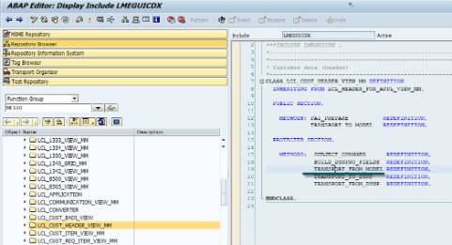](http://scn.sap.com/servlet/JiveServlet/showImage/102-55509-1-468841/6-6-2014+12-55-09+AM.jpg)

[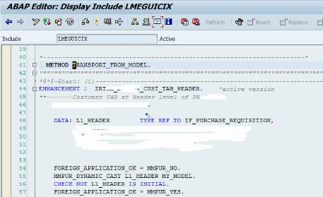](http://scn.sap.com/servlet/JiveServlet/showImage/102-55509-1-468848/6-6-2014+12-58-33+AM.jpg)

DATA: L1_HEADER        TYPE REF TO IF_PURCHASE_REQUISITION.  
           
    FOREIGN_APPLICATION_OK = MMPUR_NO.  
    MMPUR_DYNAMIC_CAST L1_HEADER MY_MODEL.  
    CHECK NOT L1_HEADER IS INITIAL.  
    FOREIGN_APPLICATION_OK = MMPUR_YES.  
    
**---Export values to PBO of Custom Screen 999 of SAPLXM02- to use in PBO

      EXPORT L1_HEADER from L1_HEADER to MEMORY id 'REq@Header_value'.  
           
    EXIT."Over write Standard Implementation -**THIS IS MANDATORY**

            Now, we are all set to call transaction ME51N to view Custom tab in Header level in Purchase Requisition

[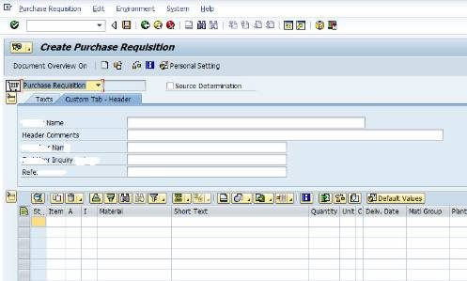](http://scn.sap.com/servlet/JiveServlet/showImage/102-55509-1-468850/6-6-2014+1-05-32+AM.jpg)

             [ Now the data part is left to you, how to handle data at PAI , PBO and fetch from Table and Save into Table .......Hope this helps at least a bit]